Practice 2A.2- Graphing Absolute Value Inequalities Name: ______________________

For each problem, provide a verbal description of the transformed equation and graph the equation (remember to use dashed and solid lines as necessary) and shade in the correct direction.

- $y≥|x+3|-1$

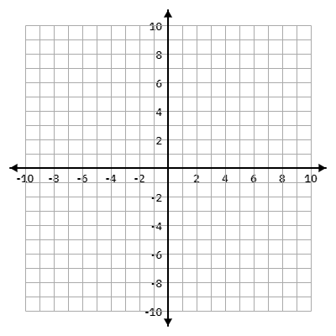

- $y≤-|2x-4|+2$
- $y>-\frac{1}{2}|x-4|+2$

- $y≥-3|x|+2$
- $y≤\frac{1}{2}|x-2|-1$

- $y<-|x-6|+1$
- $y>4|x+1|-2$

- $y<|3x+12|$

